

SAFEGUARDING
You have a duty to refer any child protection concerns
The child protection designated lead is Mr Roger Hardy
The deputy leads are Mrs Kath Wood and Mrs Laura Sheldon
The named governor for child protection is Mrs Louise Neate
- Report immediately any concerns to the designated Child protection officer or deputies.
- Do not leave site until you have reported your concern.
- If you are offsite or out of hours please call Social Services duty desk on 01446 725202/07701294662
If you have any safeguarding concerns about a child please report it straight away.
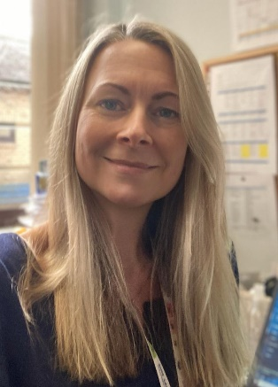
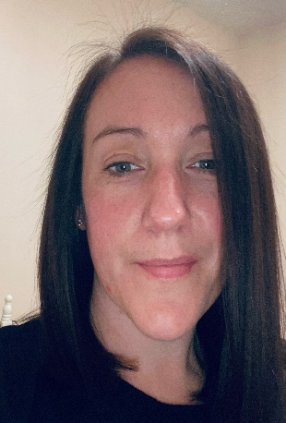
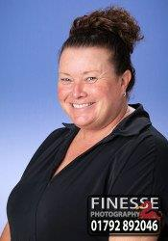
Mr Hardy Mrs Sheldon Mrs Neate Mrs Wood
Safeguarding lead Deputy Safeguarding GB safeguarding Deputy Safeguarding
Lead Lead Lead

