

SAFEGUARDING
You have a duty to refer any child protection concerns
The child protection designated lead is Mr Roger Hardy
The deputy leads are Mrs Cheryl Poiner and Mrs Laura Sheldon
The named governor for child protection is Mrs Paula Speed
- Report immediately any concerns to the designated Child protection officer or deputies.
- Do not leave site until you have reported your concern.
- If you are offsite or out of hours please call Social Services duty desk on 0808 2816727/07701294662
If you have any safeguarding concerns about a child please report it straight away.
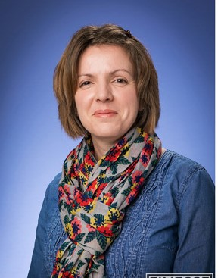
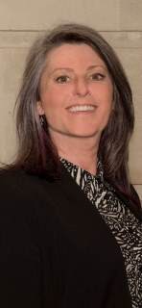
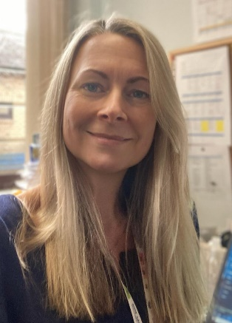

Mr Hardy Mrs Sheldon Mrs Speed Mrs Poiner
Safeguarding lead Deputy Safeguarding GB safeguarding Deputy Safeguarding
Lead Lead Lead

